**1.Write a c program to evaluate the code for bubble sorting**

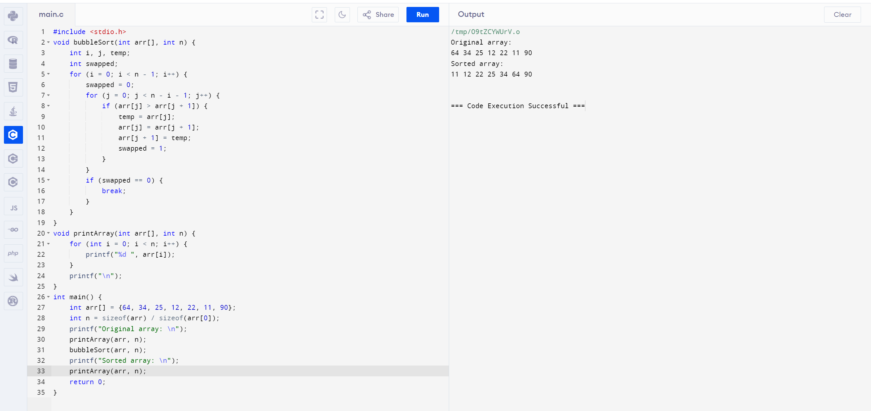

**2.Write a c program to evaluate the selection sorting**

